**CSW1 (CSE 3141) ASSIGNMENT ON**

**OOPS**

**NAME:** Ashutosh Dash

**REGD. NO:** 1941012274

**SECTION:** Q

**SUBJECT:** Computer Science Workshop 1

**SEMESTER:** 3rd

**YEAR:** 2nd

**BRANCH:** CSE

**1.**

**class students {**

**private String name;**

**private int roll,age;**

**public students(String name, int roll, int age) {**

**this.name = name;**

**this.roll = roll;**

**this.age=age;**

**}**

**public String toString() {**

**return String.format("Name: "+name+","+" Roll: "+roll+","+" Age: "+age);**

**}**

**}**

**public class A8P1 {**

**public static void main(String[] args) {**

**students ob = new students("Ashutosh Dash", 274, 19);**

**System.out.println(ob);**

**}**

**}**

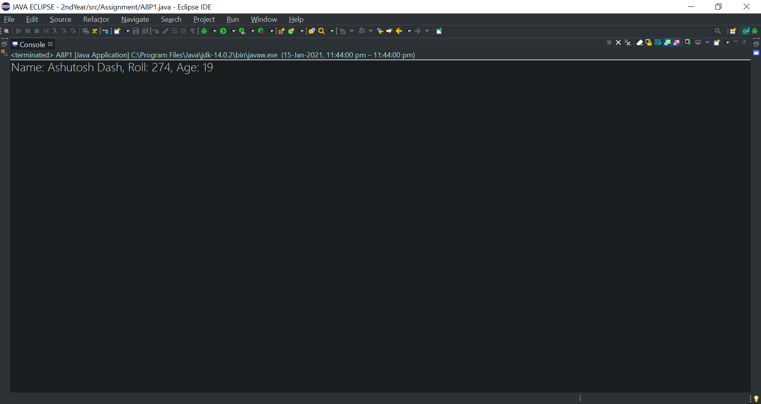**OUTPUT**

**2.**

**import java.util.Scanner;**

**class STUDENT {**

**private String name;**

**private int roll,age;**

**public STUDENT(String name, int roll, int age) {**

**this.name = name;**

**this.roll = roll;**

**this.age=age;**

**}**

**public String toString() {**

**return String.format("Name: "+name+","+" Roll: "+roll+","+" Age: "+age);**

**}**

**}**

**public class A8P2 {**

**public static void main(String[] args) {**

**Scanner sc=new Scanner(System.in);**

**STUDENT x= new STUDENT("Ashutosh Dash", 274, 19);**

**STUDENT y= new STUDENT("Ashutosh Dash", 274, 19);**

**STUDENT z= new STUDENT("Ashutosh Dash", 274, 19);**

**if(x.equals(x))**

**System.out.println("Its reflexive");**

**else**

**System.out.println("Its not reflexive");**

**if(x.equals(y)==y.equals(x))**

**System.out.println("Its symmetric");**

**else**

**System.out.println("Its not symmetric");**

**boolean b=(x.equals(y) && y.equals(z));**

**if(b==x.equals(z))**

**System.out.println("Its transitive");**

**else**

**System.out.println("Its not transitive");**

**int i=0;**

**System.out.println("Enter the no.of times you want the loop to run");**

**int j=sc.nextInt();**

**while(i<j) {**

**boolean k=x.equals(y);**

**if(k==x.equals(y)) {**

**System.out.println("Its repeatitive");**

**k=x.equals(y);**

**}**

**else**

**System.out.println("Its not repeatitive");**

**i++;**

**}**

**if((x.equals(null)==false))**

**System.out.println("Its cautious");**

**else**

**System.out.println("Its not cautious");**

**}**

**}**

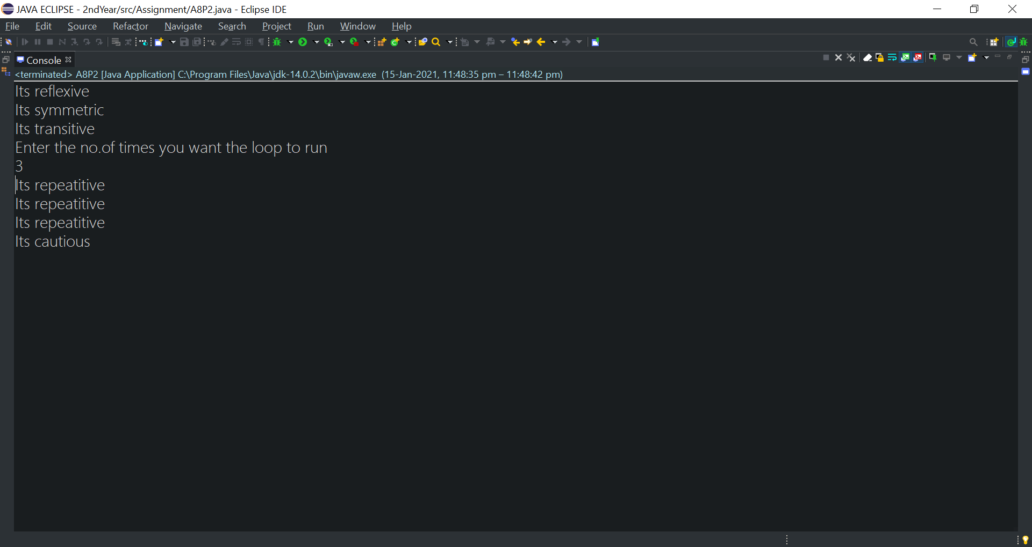**OUTPUT**

**3.**

**import java.util.regex.Matcher;**

**import java.util.regex.Pattern;**

**class MyException extends Exception {**

**String str1;**

**MyException(String str2) {**

**str1=str2;**

**}**

**public String toString() {**

**return("Exception occured: "+str1);**

**}**

**}**

**class Car {**

**public String chassis,color;**

**public int mspeed;**

**public Car(String chassis, String color, int mspeed) {**

**this.chassis = chassis;**

**this.color = color;**

**this.mspeed=mspeed;**

**}**

**public String toString() {**

**return String.format("Chassis: "+chassis+","+" Color: "+color+","+" MaxSpeed: "+mspeed+"km/h");**

**}**

**}**

**public class A8Q3 {**

**public static void main(String[] args) {**

**try {**

**Car ob=new Car("IR734VX02","Blue",85);**

**if(ob.chassis.length()>=10)**

**throw new MyException("Invalid no. of Chassis characters");**

**String regex = "^(?=.*[a-zA-Z])(?=.*[0-9])[A-Za-z0-9]+$";**

**Pattern p = Pattern.compile(regex);**

**Matcher m = p.matcher(ob.chassis);**

**if(!m.matches())**

**throw new MyException("Invalid Chassis input (not alphanumeric)");**

**else**

**System.out.println(ob);**

**}**

**catch(MyException m) {**

**System.out.println(m);**

**}**

**}**

**}**

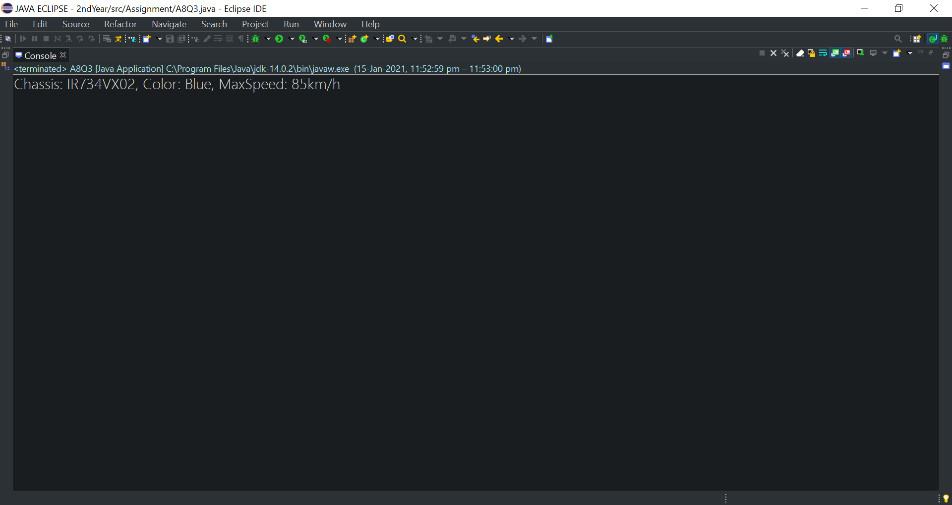**OUTPUT**

**4.**

**import java.util.Scanner;**

**class Shape {**

**double len,hei,base,rad;**

**float wid;**

**Shape(double l,float w) {**

**len=l;**

**wid=w;**

**}**

**Shape(double b,double h) {**

**base=b;**

**hei=h;**

**}**

**Shape(double r) {**

**rad=r;**

**}**

**}**

**class Rectangle extends Shape {**

**Rectangle(double l,float w) {**

**super(l,w);**

**}**

**void area() {**

**double R=len*wid;**

**System.out.println("Area of Rectangle = "+R);**

**}**

**}**

**class Triangle extends Shape {**

**Triangle(double b,double h) {**

**super(b,h);**

**}**

**void area() {**

**double T=0.5*base*hei;**

**System.out.println("Area of Triangle = "+T);**

**}**

**}**

**class Circle extends Shape {**

**Circle(double r) {**

**super(r);**

**}**

**void area() {**

**double C=Math.PI*rad*rad;**

**System.out.println("Area of Circle = "+C);**

**}**

**}**

**public class A8Q4 {**

**public static void main(String[] args) {**

**Scanner sc=new Scanner(System.in);**

**System.out.println("Enter length and width:");**

**double l=sc.nextDouble();**

**float w=sc.nextFloat();**

**Rectangle or=new Rectangle(l, w);**

**or.area();**

**System.out.println("Enter base and height:");**

**double b=sc.nextDouble();**

**double h=sc.nextFloat();**

**Triangle ot=new Triangle(b, h);**

**ot.area();**

**System.out.println("Enter radius:");**

**double r=sc.nextDouble();**

**Circle oc=new Circle(r);**

**oc.area();**

**}**

**}**

**OUTPUT**

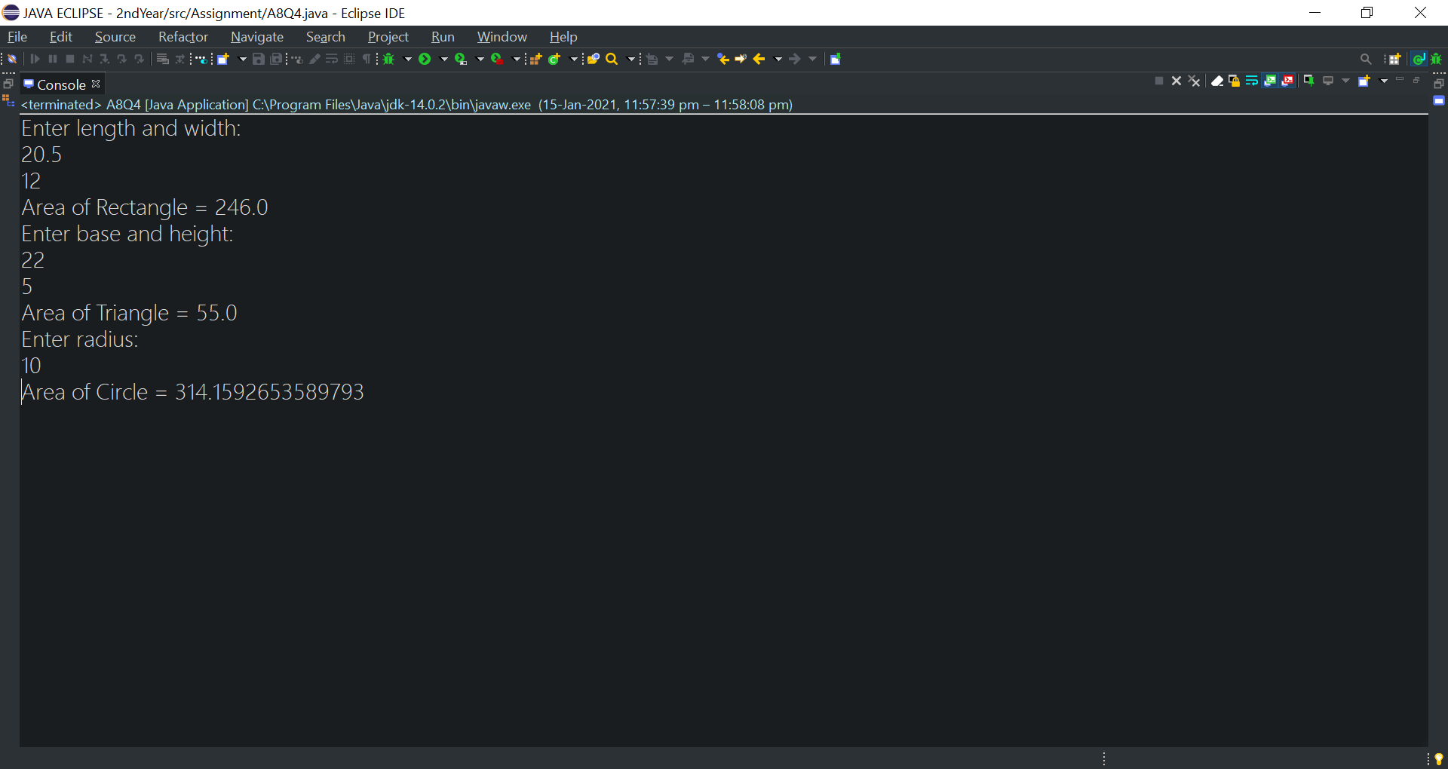

**5.**

**import java.util.*;**

**class MutableInteger {**

**private int i;**

**public void set(int i) {**

**this.i=i;**

**}**

**public int get() {**

**return i;**

**}**

**public void incr(int incr) {**

**i=i+incr;**

**}**

**}**

**public class A8Q5 {**

**public static void main(String[] args) {**

**Scanner sc=new Scanner(System.in);**

**System.out.println("enter a no.");**

**MutableInteger m=new MutableInteger();**

**m.set(sc.nextInt());**

**System.out.println("no. entered: "+m.get());**

**System.out.println("enter the increment no.");**

**m.incr(sc.nextInt());**

**System.out.println("incremented no. "+m.get());**

**}**

**}**

**OUTPUT**

